Computer Networks
HOMEWORK #5
Due date: 2025-06-01
NOTE: WRITE YOUR ANSWERS IN ENGLISH.
ID#:2022310865 Name: (Kor.)배민수 (Eng.)Minsoo Bae
Problem # 6. (30pts) Final Web-based Network Application with Chat, File Transfer, Video Streaming, Ollama, and External APIs Integration
In this problem, you will develop a final integrated web-based network application based on the concepts practiced in previous homeworks. HW1 implemented TCP/UDP client-server communication, HW2 focused on authenticated multi-client chatting, and HW4 implemented video streaming. In HW5, you will integrate these ideas into one messenger-style web application.
The goal of this homework is to practice building a complete application-layer network system using HTTP, WebSocket, database storage, file transfer, external APIs, and local LLM APIs. Your application should provide the following major functions:
- user authentication,
- real-time user-to-user chatting,
- file upload and download through chat,
- an Ollama-based AI assistant,
- weather information using an external API,
- and a server-provided video streaming room.
The application does not need to use webcam streaming, live camera input, WebRTC, or real-time video broadcasting. The video streaming room only needs to serve a prepared video file, such as sample.mp4, from the server.
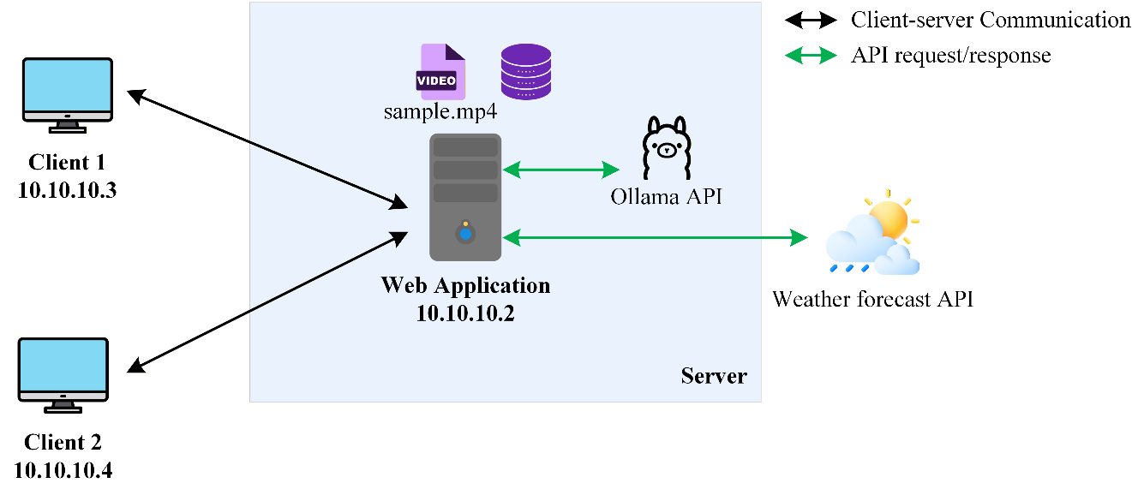
Figure 1. Messenger-style web application integrating chat, file transfer, video streaming, local LLM, and external API services.
Functional Requirements
Implement a web-based messenger application with the following functions:
- User authentication
- Users must be able to sign up, log in, and log out.
- User information must be stored in a SQLite database.
- Passwords must be stored as hashes, not as plain-text passwords.
- The server must manage user sessions after login.
- Messenger-style user list
- The application must show all registered users.
- Online users must be marked with a green status indicator.
- Offline users must be marked with a gray status indicator.
- The user list should be updated when users log in or log out.
- Real-time chat
- Users must be able to select another user and exchange messages.
- Messages should be delivered in real time when both users are online.
- WebSocket or an equivalent real-time communication mechanism should be used.
- Chat history must be stored in the SQLite database.
- When a user opens a previous conversation, the stored chat history should be displayed.
- File transfer
- Users must be able to attach and send files through the chat interface.
- Uploaded files must be saved on the server.
- File information should be stored in the database.
- The receiver should be able to download the file from the chat interface.
- The report should include screenshots showing both file upload and file download.
- Video streaming room
- The application must include a video streaming page or room.
- The server should provide a prepared video file, such as sample.mp4.
- Multiple users should be able to open the streaming room and watch the server-provided video.
- You do not need to implement webcam streaming, live camera streaming, WebRTC, or real-time video broadcasting.
- The video file should not be included in the submitted source code if it is large. Instead, explain where the video file should be placed and how it should be named.
- Ollama AI assistant
- The application must include an AI assistant contact, such as Ollama.
- This AI assistant should always appear online in the user list.
- When the user chats with this contact, the server should send the user’s message to the local Ollama API.
- The generated response from Ollama should be returned and displayed in the chat interface.
- Streaming token-by-token output is not required.
- You may use any installed Ollama model, but llama3.2:3b is recommended.
- External weather API
- The application must use at least one external weather API.
- Today’s weather information should be displayed in the web interface, for example in the top-right corner of the messenger page.
- It is acceptable to use a fixed city, such as Seoul, or to allow the user to enter a city.
- The browser should request weather information from your server.
- Your server should then call the external weather API and return the result to the browser.
- The browser should not directly call the external weather API.
Demo:
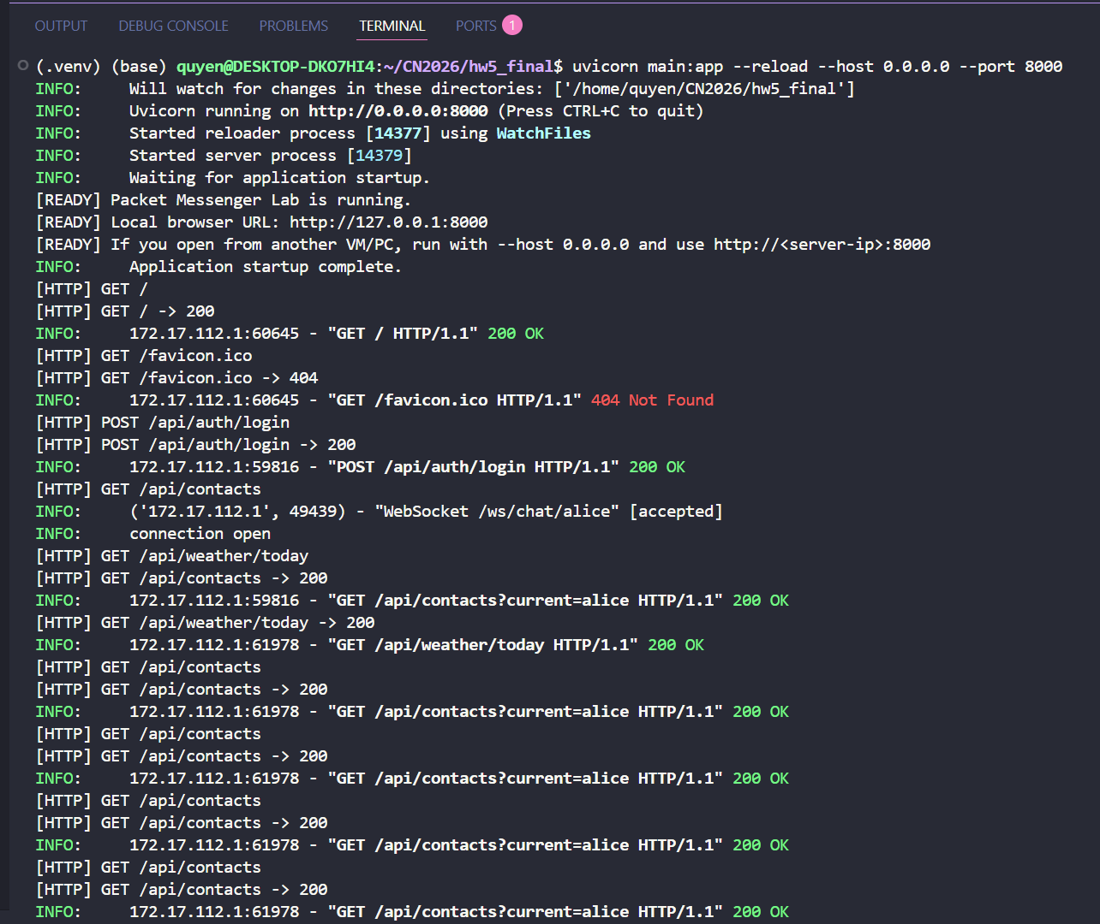
Figure 2. Server terminal while running the application
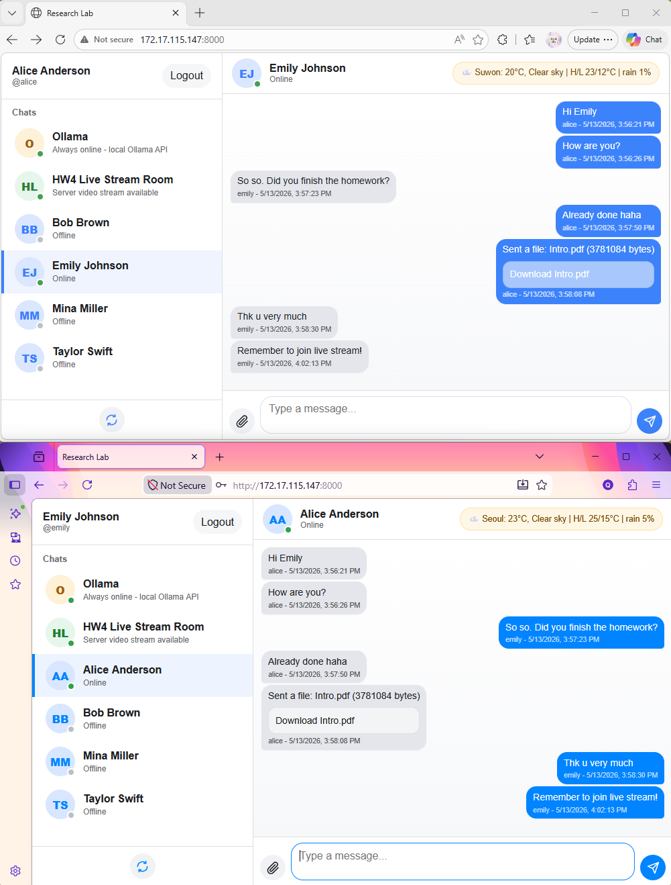
File upload/download
Weather information in the UI
Online/offline user list
Figure 3. End-to-end chat
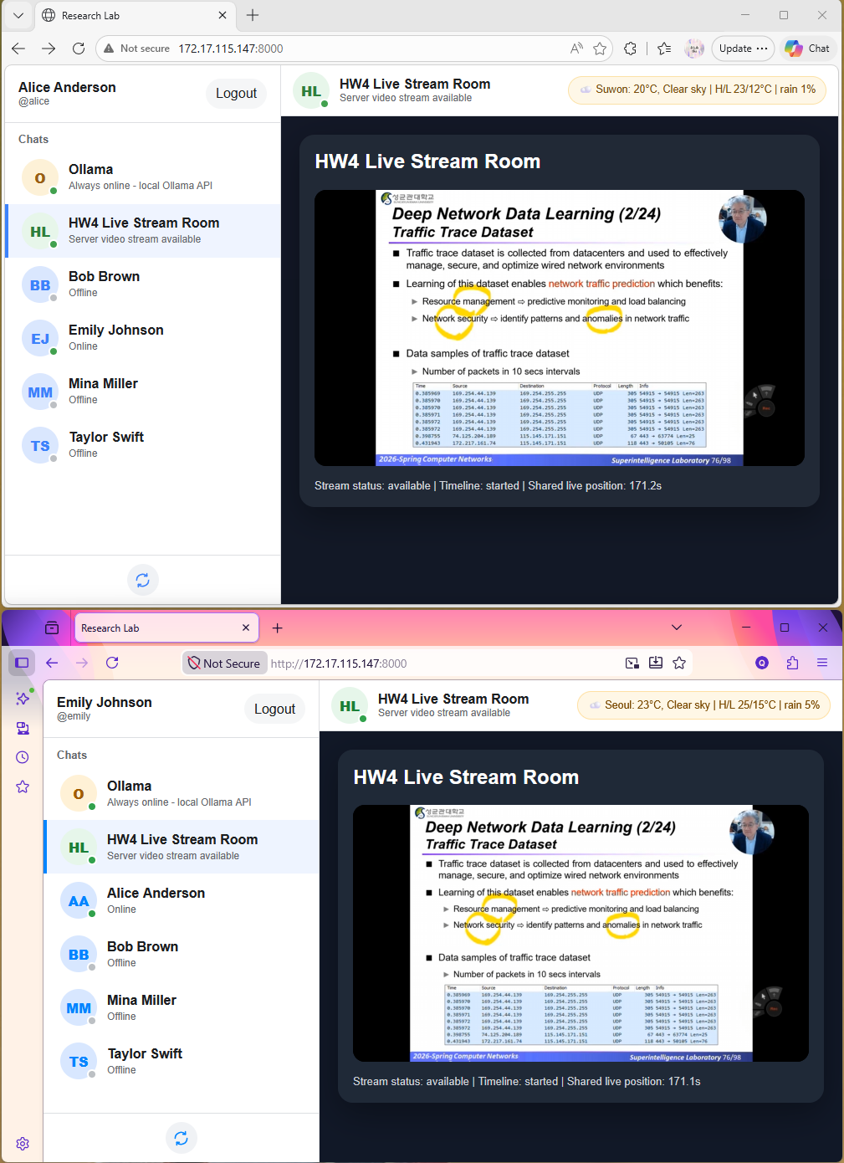
Figure 4. Video streaming room
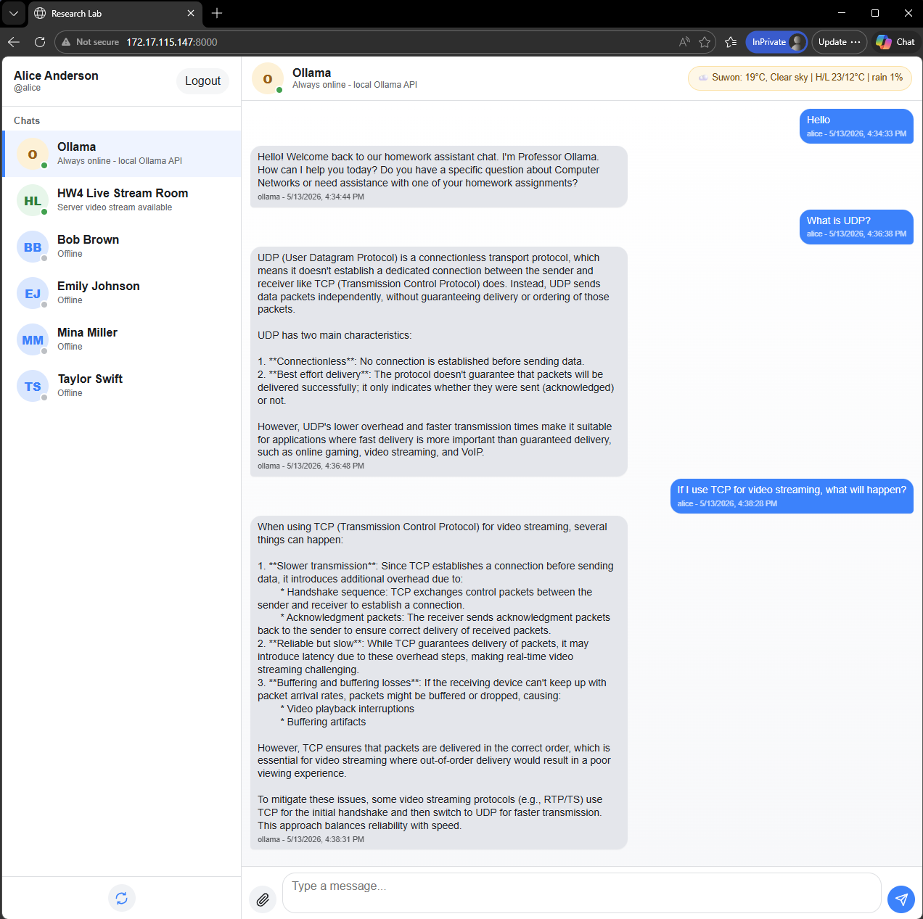
Figure 5. Chat with Ollama
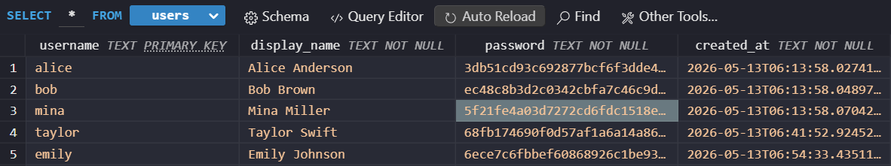
Figure 6. SQLite user table
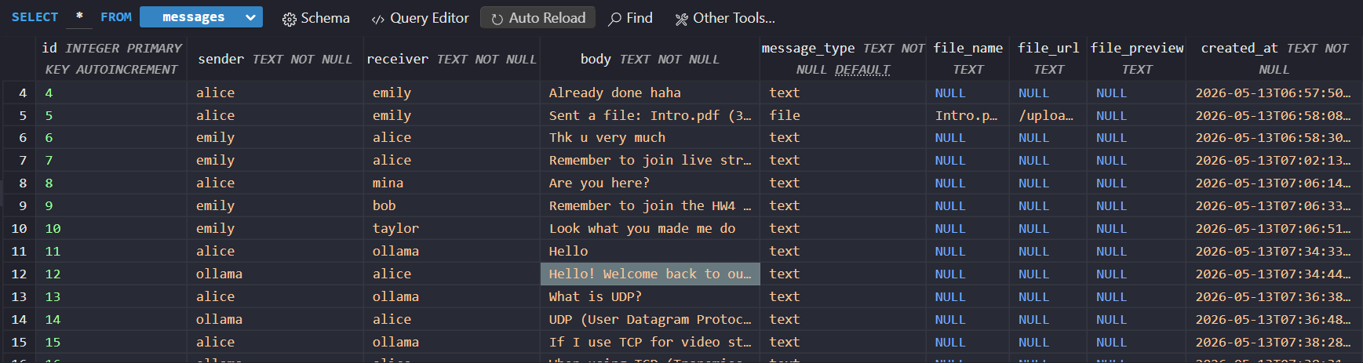
Figure 7. SQLite message or file table
Implementation requirements:
Your program must satisfy the following requirements:
- The project must be implemented as a web application.
- The server must support sign up, login, logout, and user session management.
- The server must use SQLite for user accounts and chat records, and file records.
- The web interface must show registered users and their online/offline status.
- The system must support real-time user-to-user chatting.
- The system must support file upload and download.
- The system must include an Ollama AI assistant as a special chat contact.
- The system must use at least one external weather API.
- The system must include a video streaming page or room.
- The report must explain how this final project integrates concepts from HW1, HW2, and HW4.
Hints:
You may use any programming language and framework. The following simple stack is recommended:
- Backend: Python + FastAPI + Uvicorn or another framework
- Frontend: HTML + CSS + JavaScript
- Database: SQLite3
- Real-time chat: WebSocket
- AI assistant: Ollama local API (Ref: Install Ollama, Ollama API, model llama3.2:3b)
- Weather API: Open-Meteo or another public weather API (Ref: Free Weather API)
- Video streaming: Prepared MP4 file served by the web server (Do not include it in the source code).
What to hand in:
- Screenshots: Include screenshots in your report showing all the implemeted functions. Screenshots must demonstrate multiple clients running simultaneously.
- Your implemented source codes (Attach your source code, database files).
- The command line: Provide clear instructions on HOW TO RUN your applications, either in the report or as comments in your code. Specify the exact commands for each component.
--------------------------------------------------------------------------------------------------------
Submission guidelines:
- You must submit a compressed file named CN26-HW5-ID-NAME.zip through i-Campus.
For example: CN26-HW5-2024970211-Park Chaeyoung.zip where 2024970211 is student ID and Park Chaeyoung is student NAME
- Your solution must be written in ENGLISH. Solution written in Korean will NOT be graded.
- You must use the .doc template provided on i-Campus.
There will be serious penalty for students who copy each other.

Screenshots
- User authentication
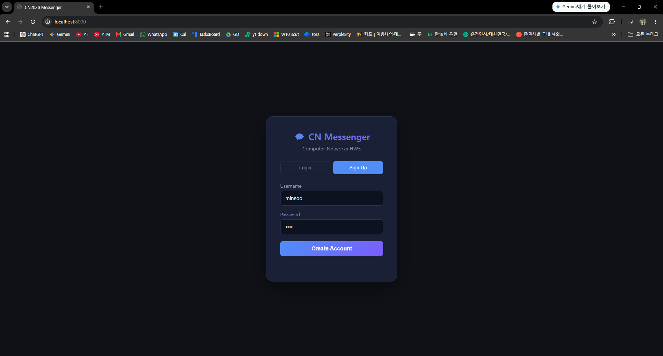
Figure 1. Signup page

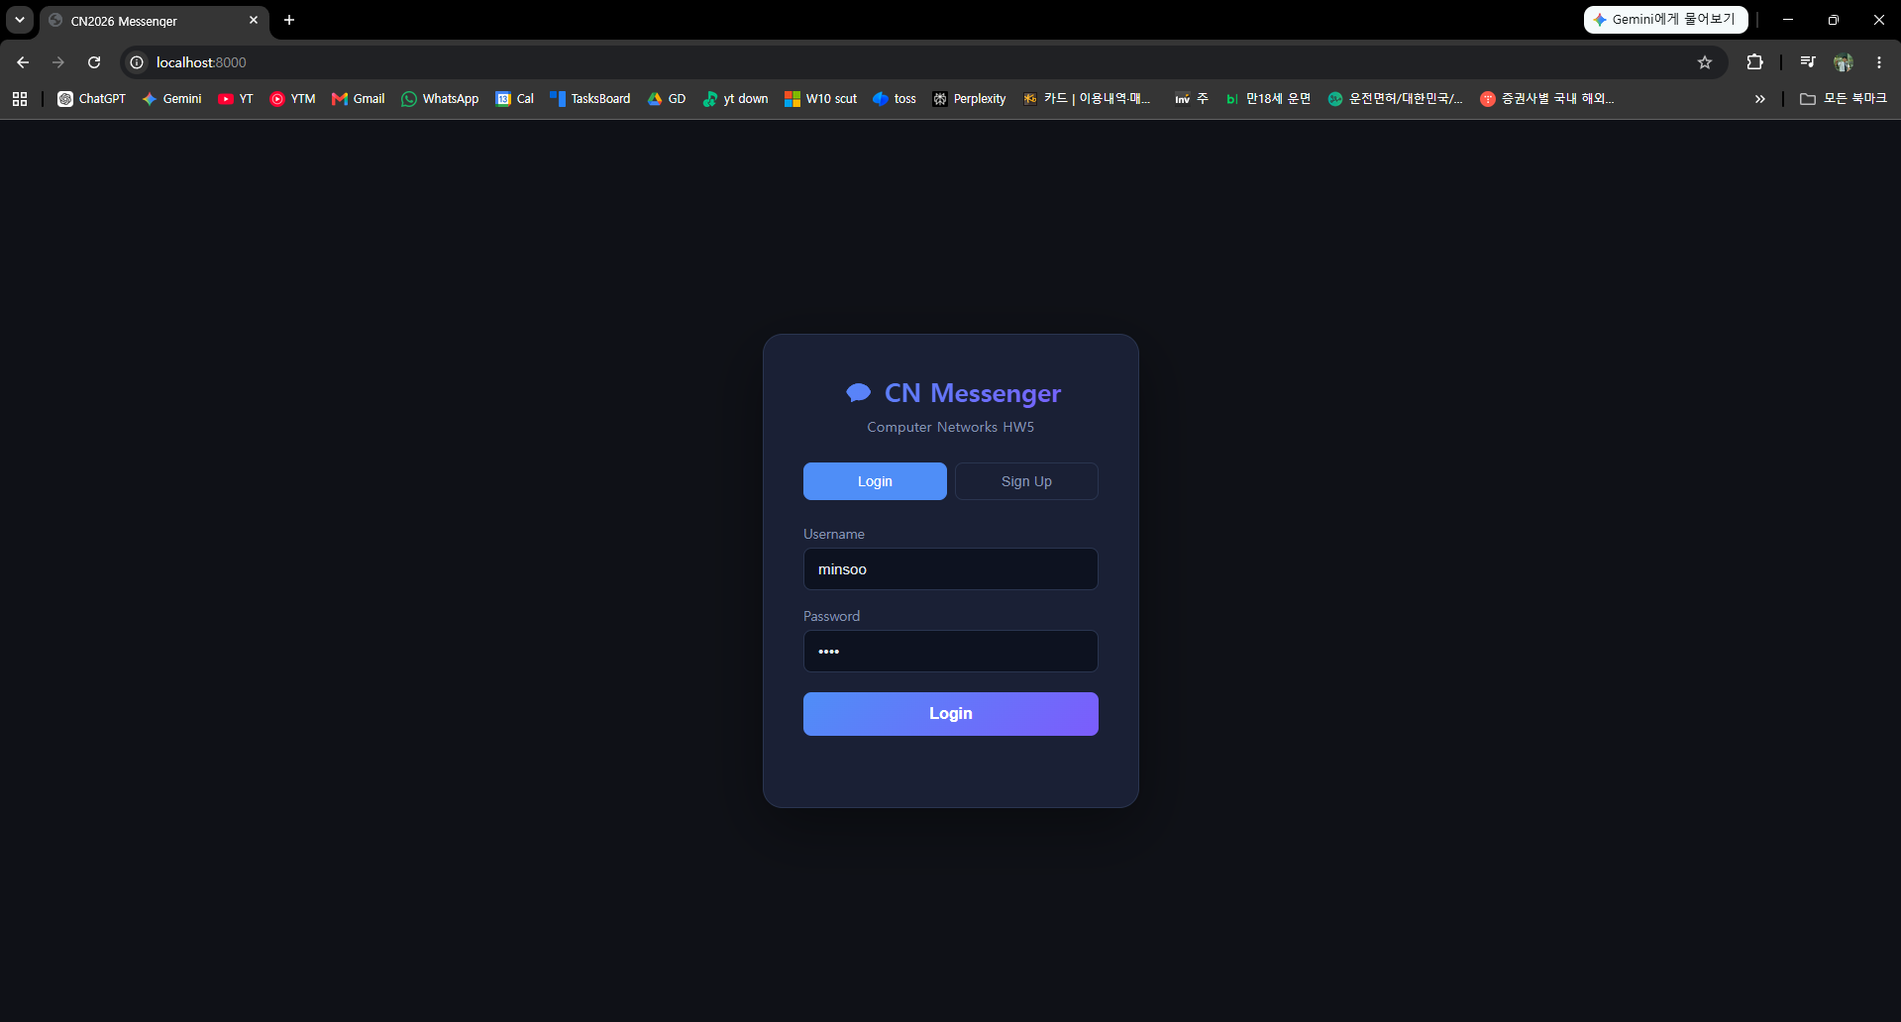
Figure 2. Login page
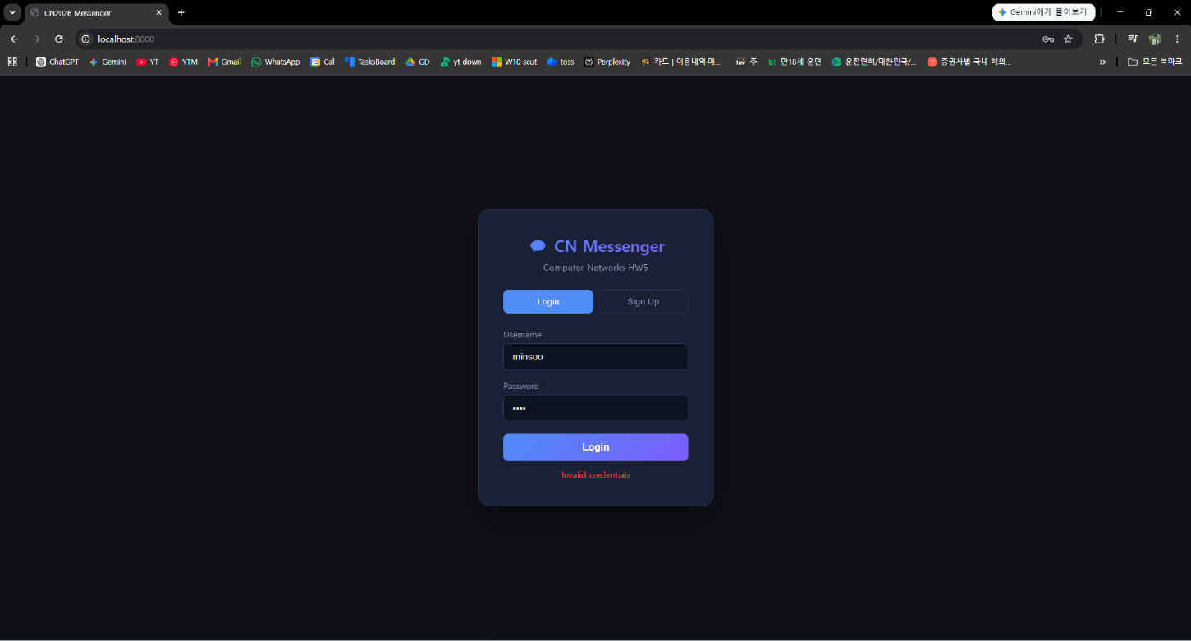
Figure 3. Login error: “Invalid credentials”

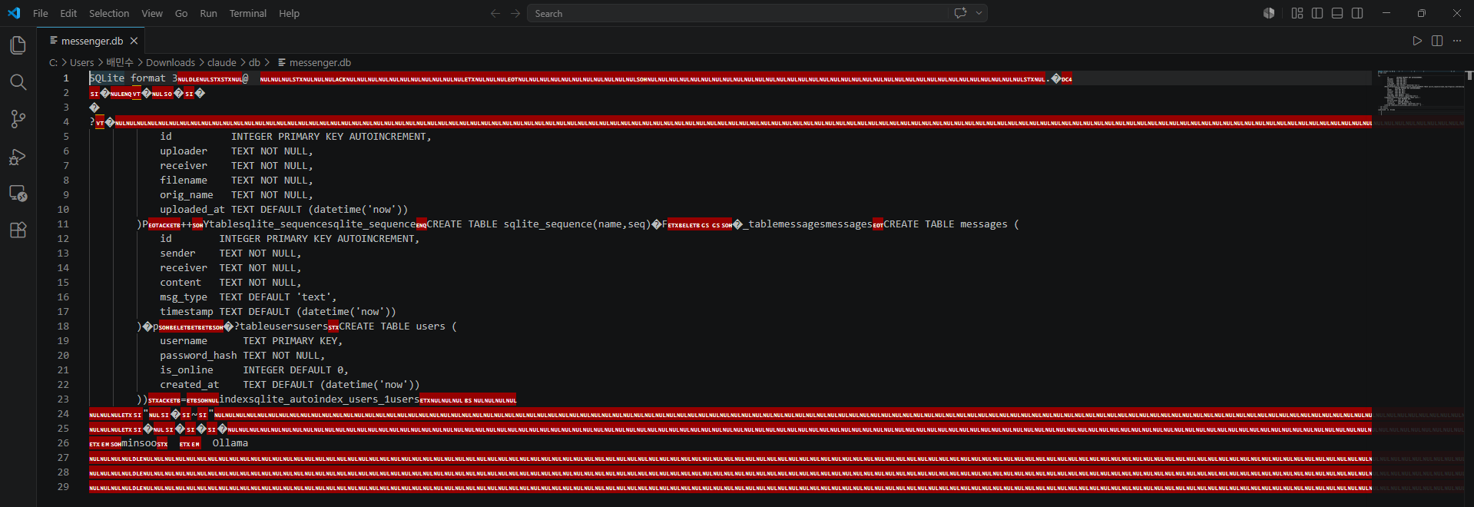
Figure 4. SQLite user table

- Messenger-style user list
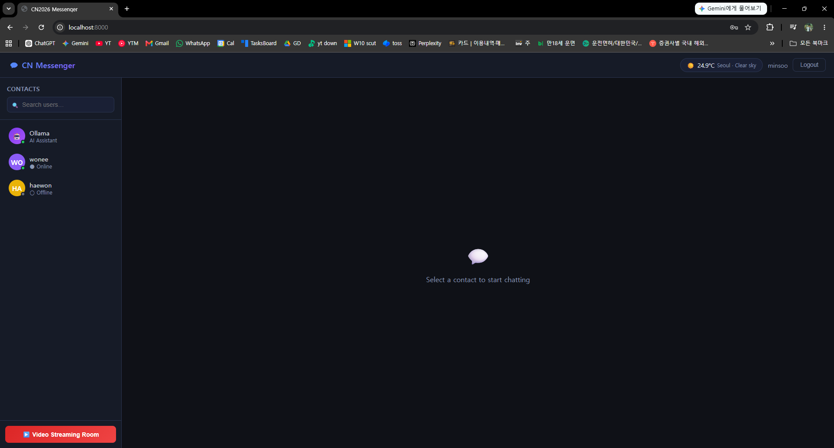
Figure 5. User list from minsoo’s account

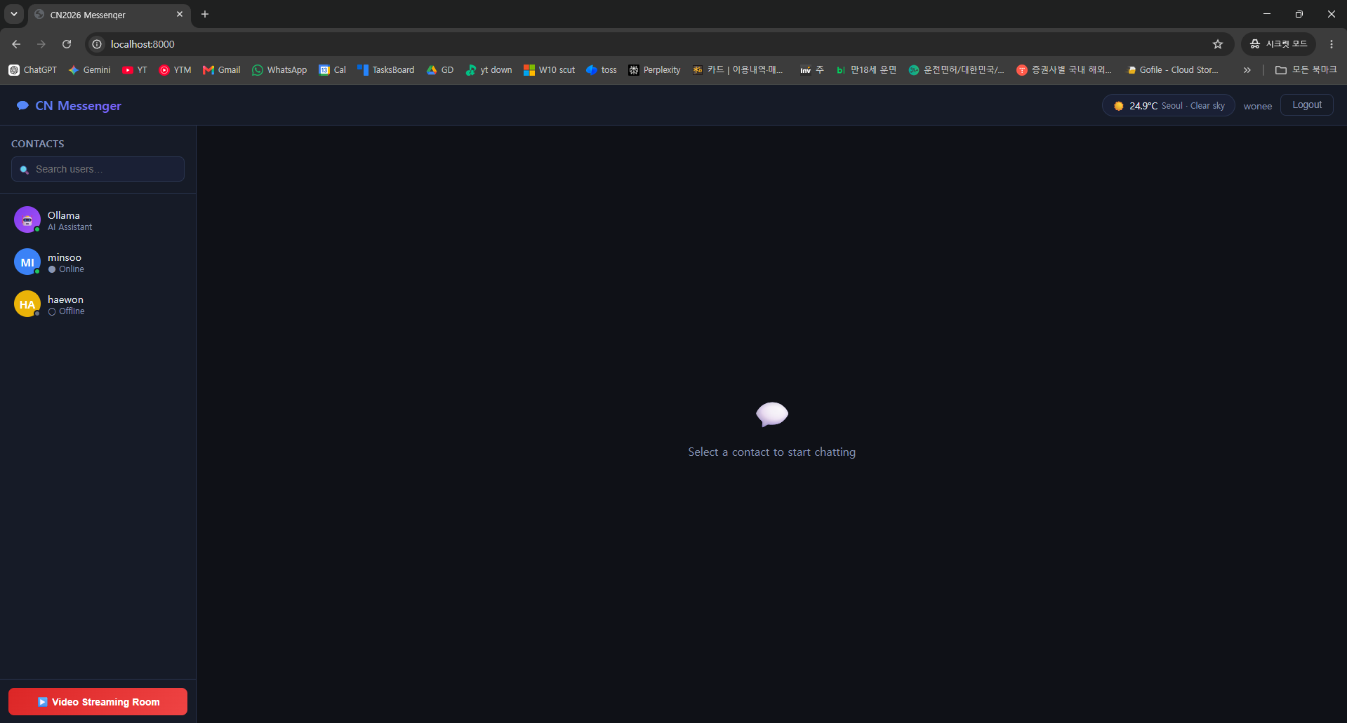
Figure 6. User list from wonee’s account
Both Figure 4 and Figure 5 shows all registered users.
Online users are marked with a green status indicator and Offline users marked with gray.
The user list is also updated when users log in or log out.
- Real-time chat & File transfer
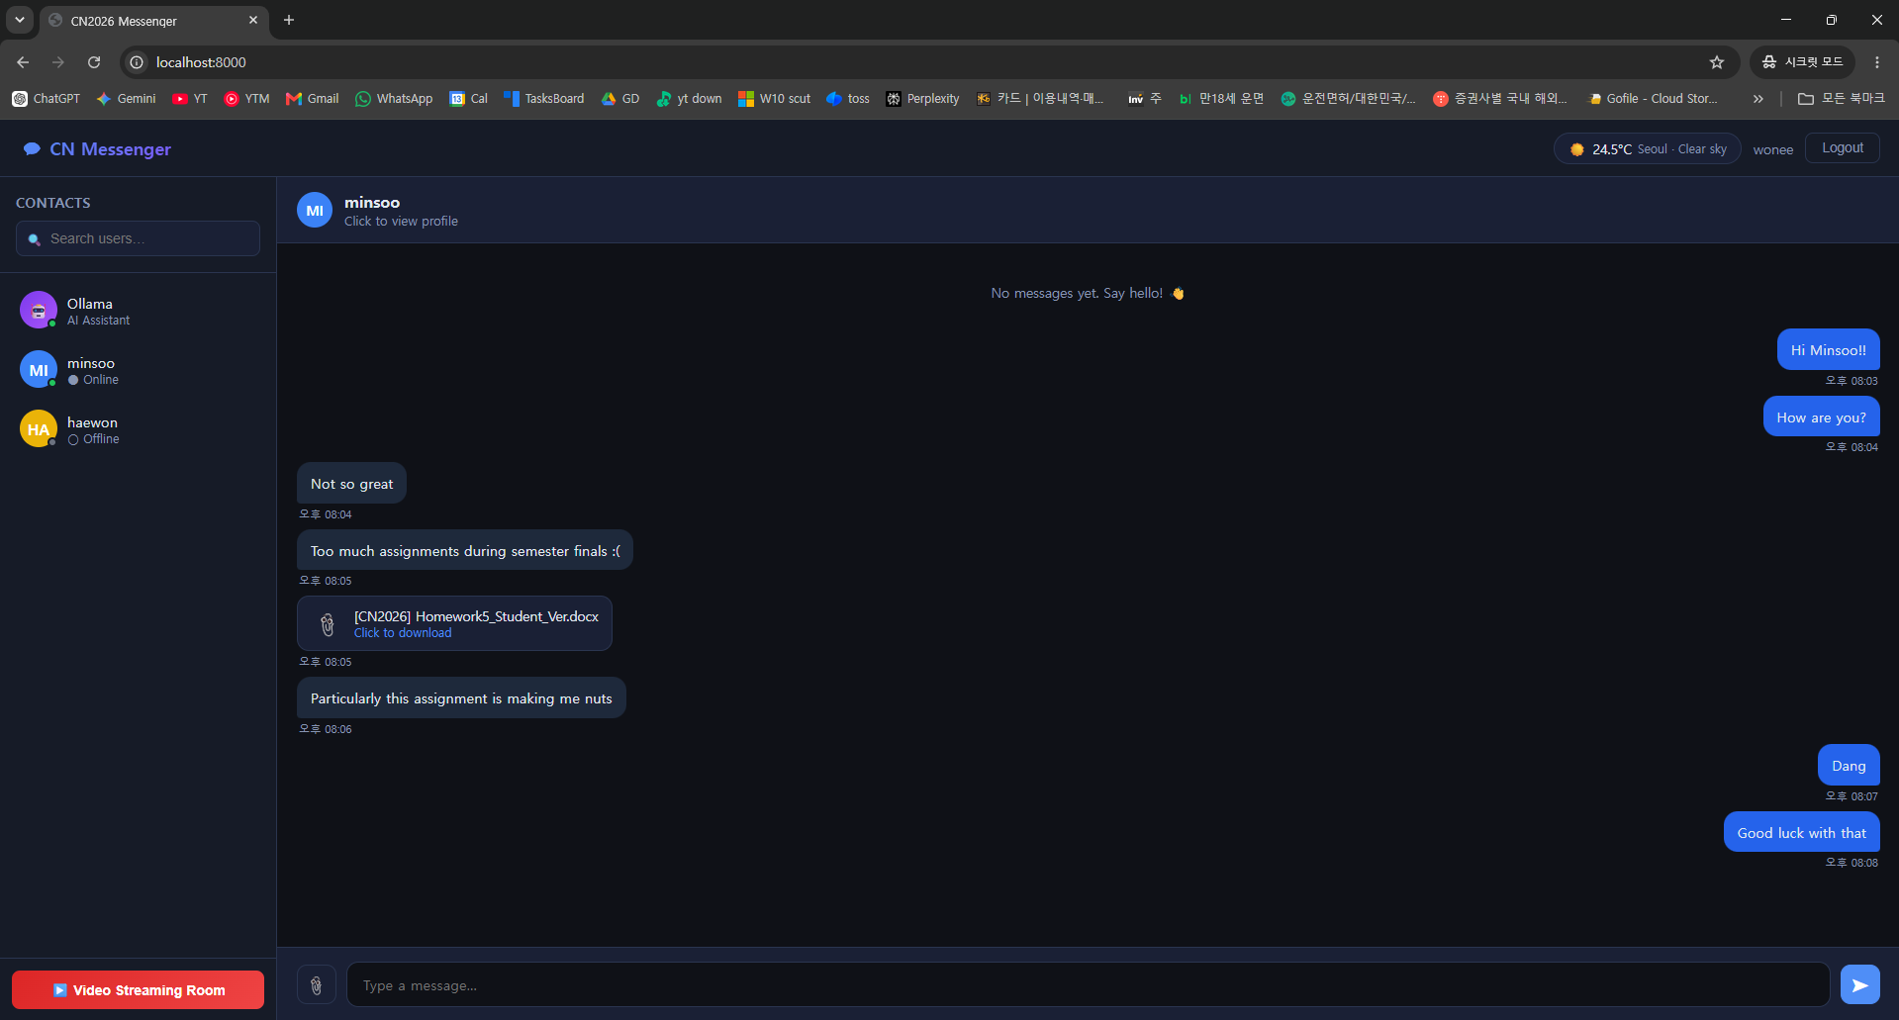
Figure 7. Real-time chat from wonee’s account

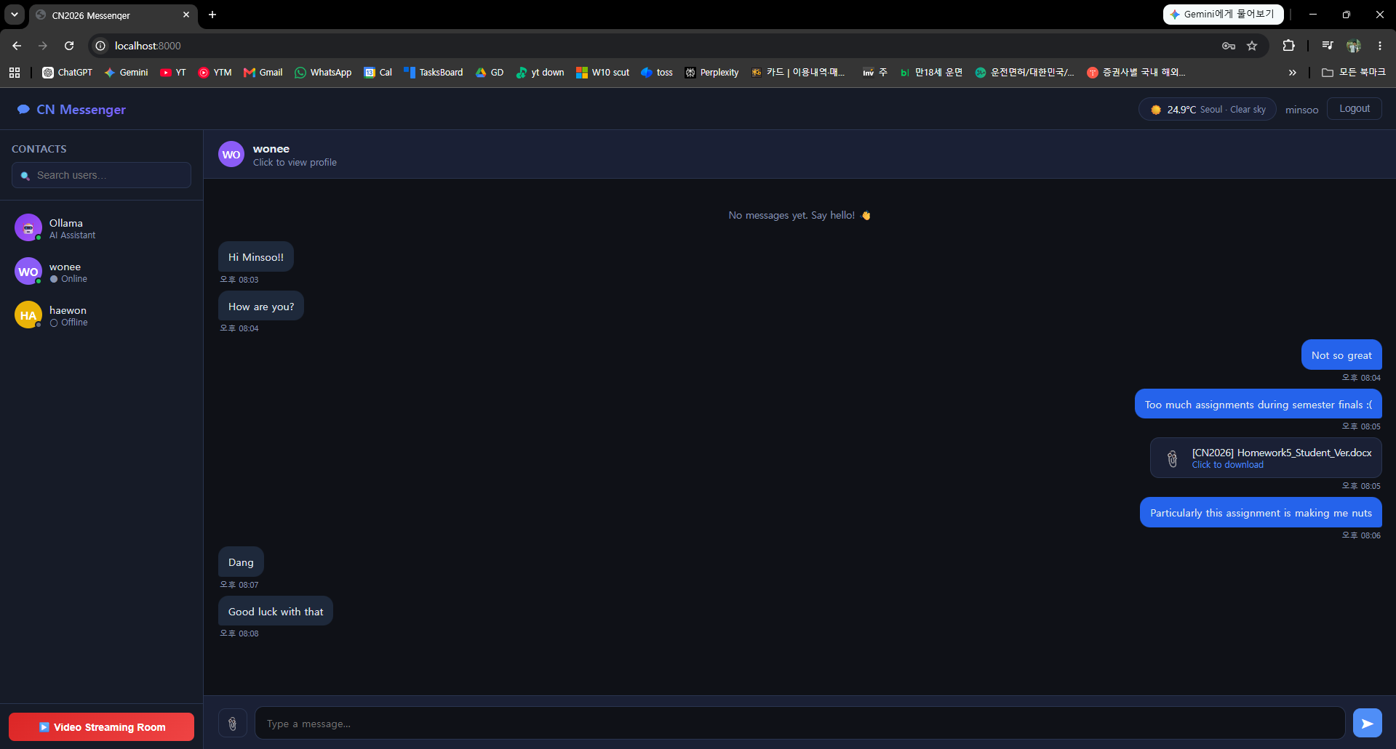
Figure 8. Real-time chat and File transfer from minsoo’s account

- Video streaming room
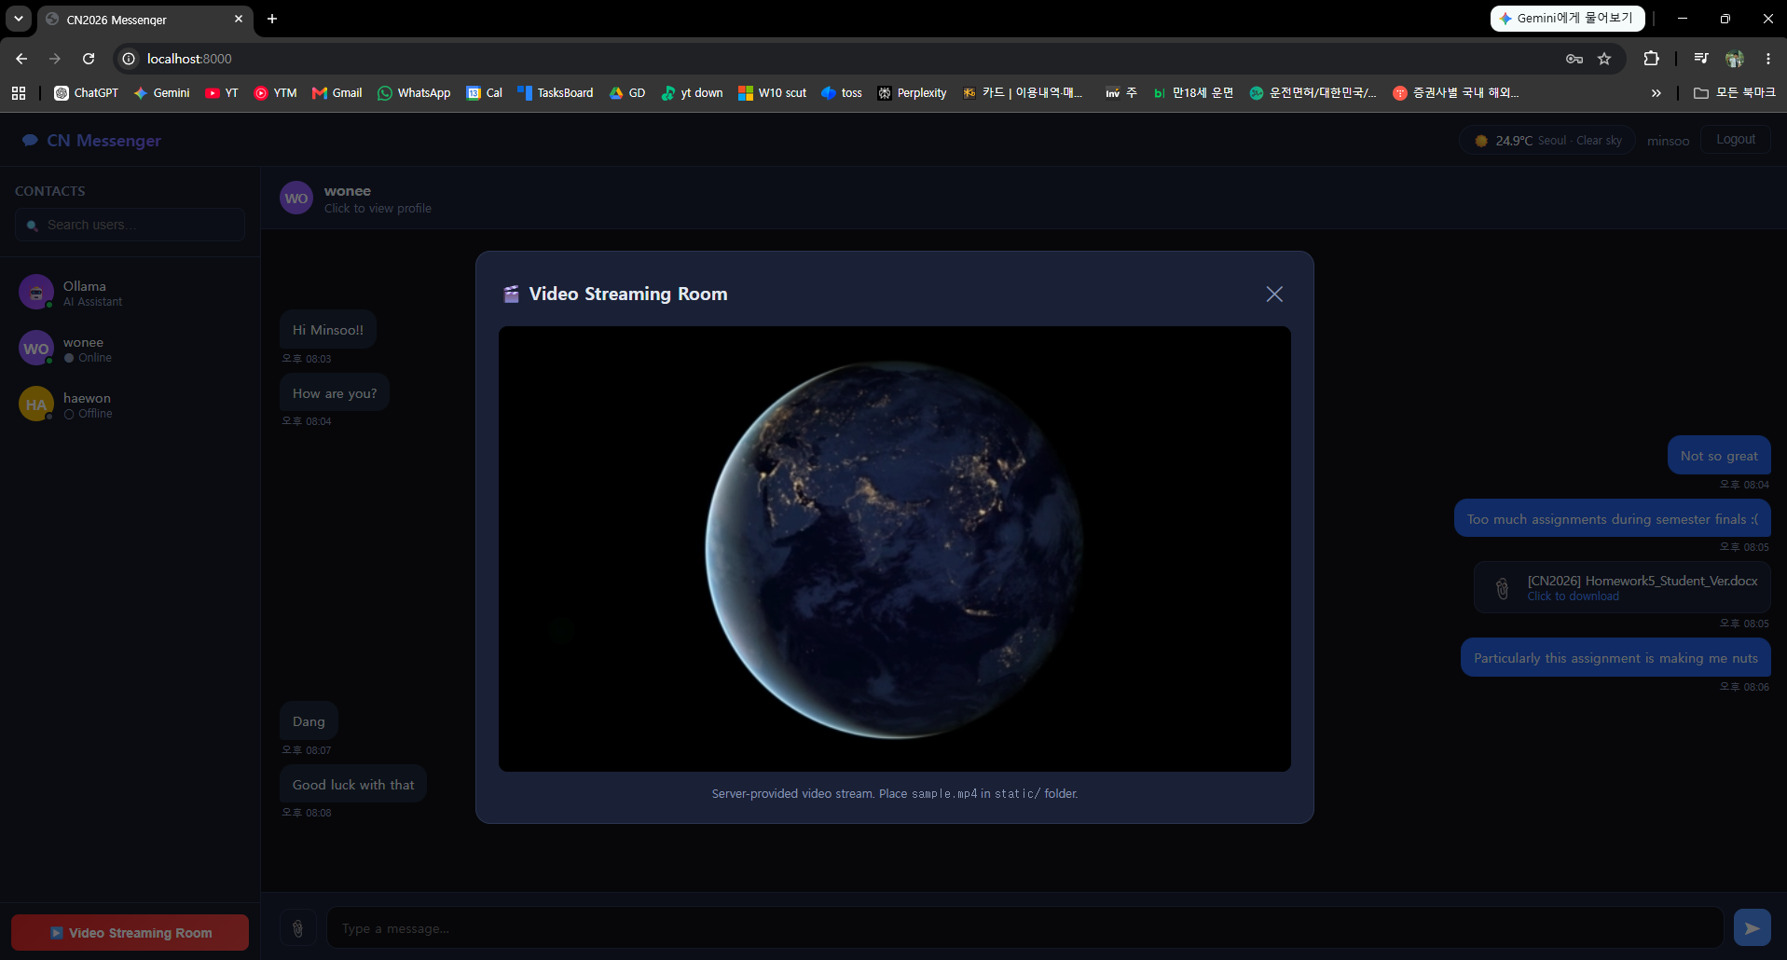
Figure 9. Video streaming room view from minsoo’s account

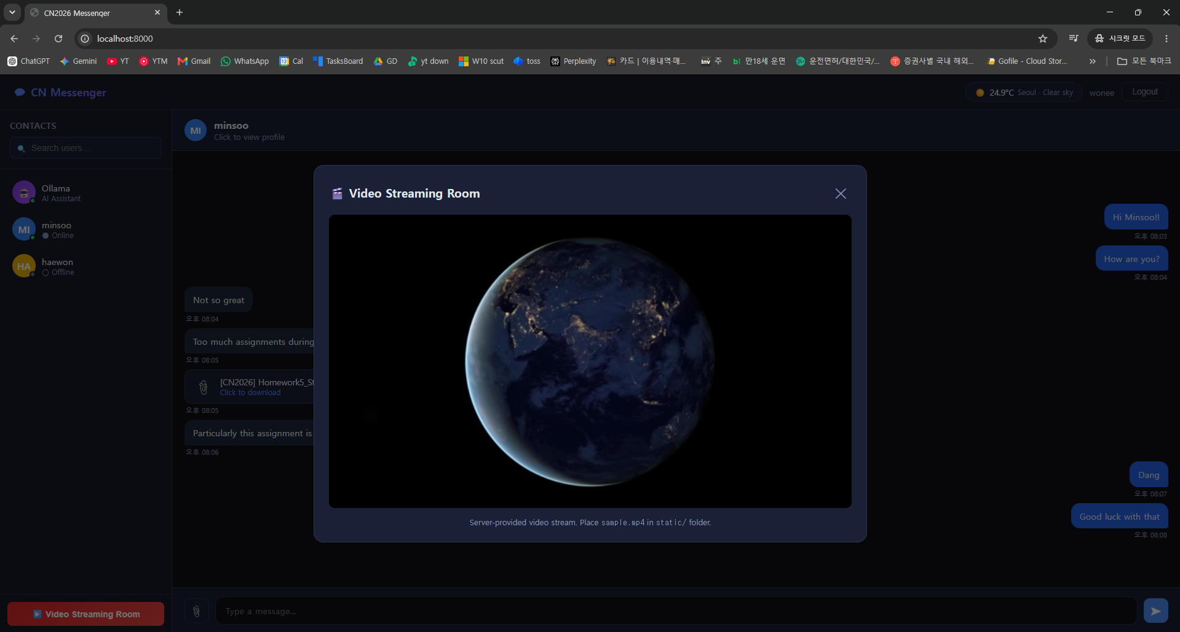
Figure 10.Video streaming room view from wonee’s account

- Ollama AI assistant
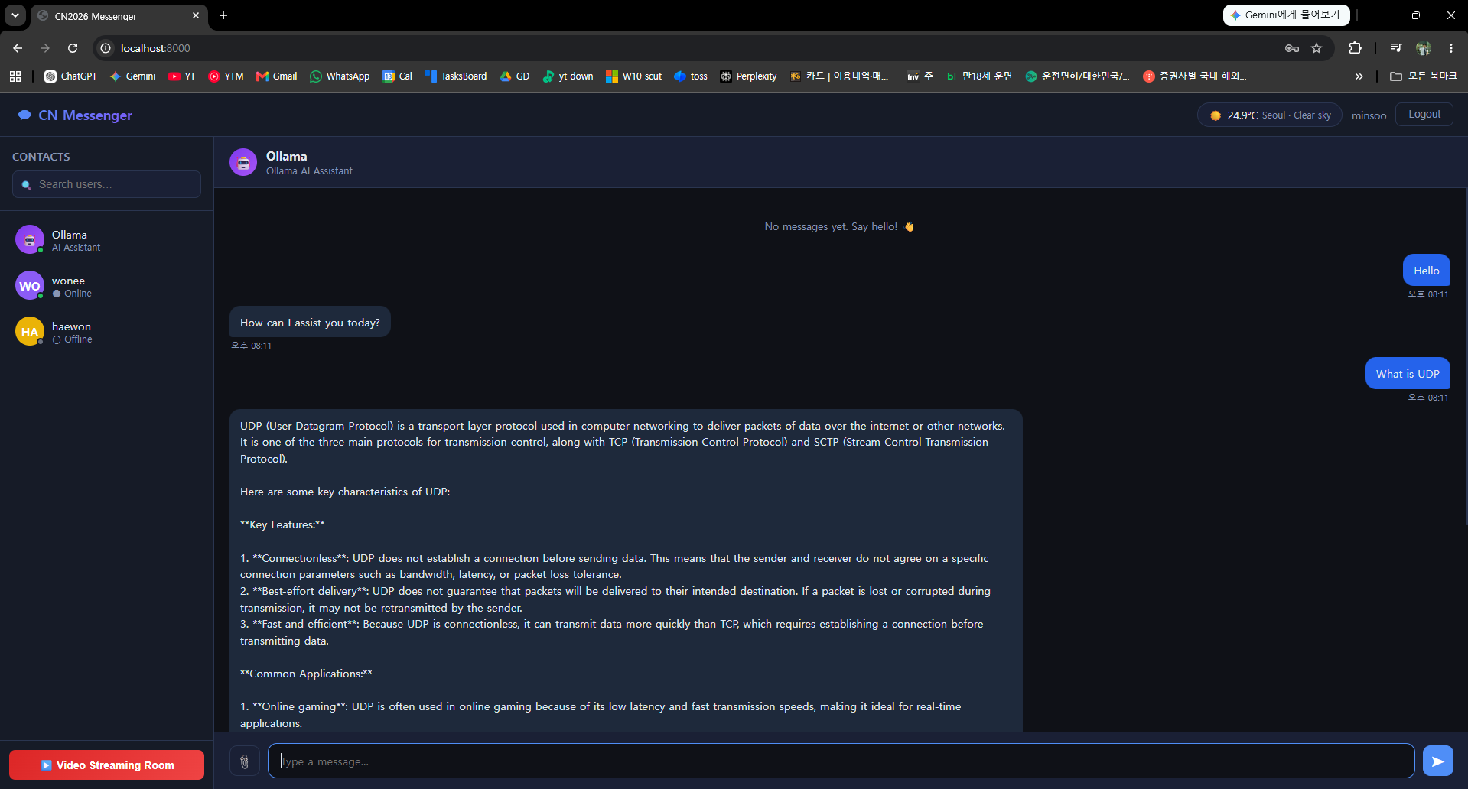
Figure 11. Chat with Ollama
- External weather API
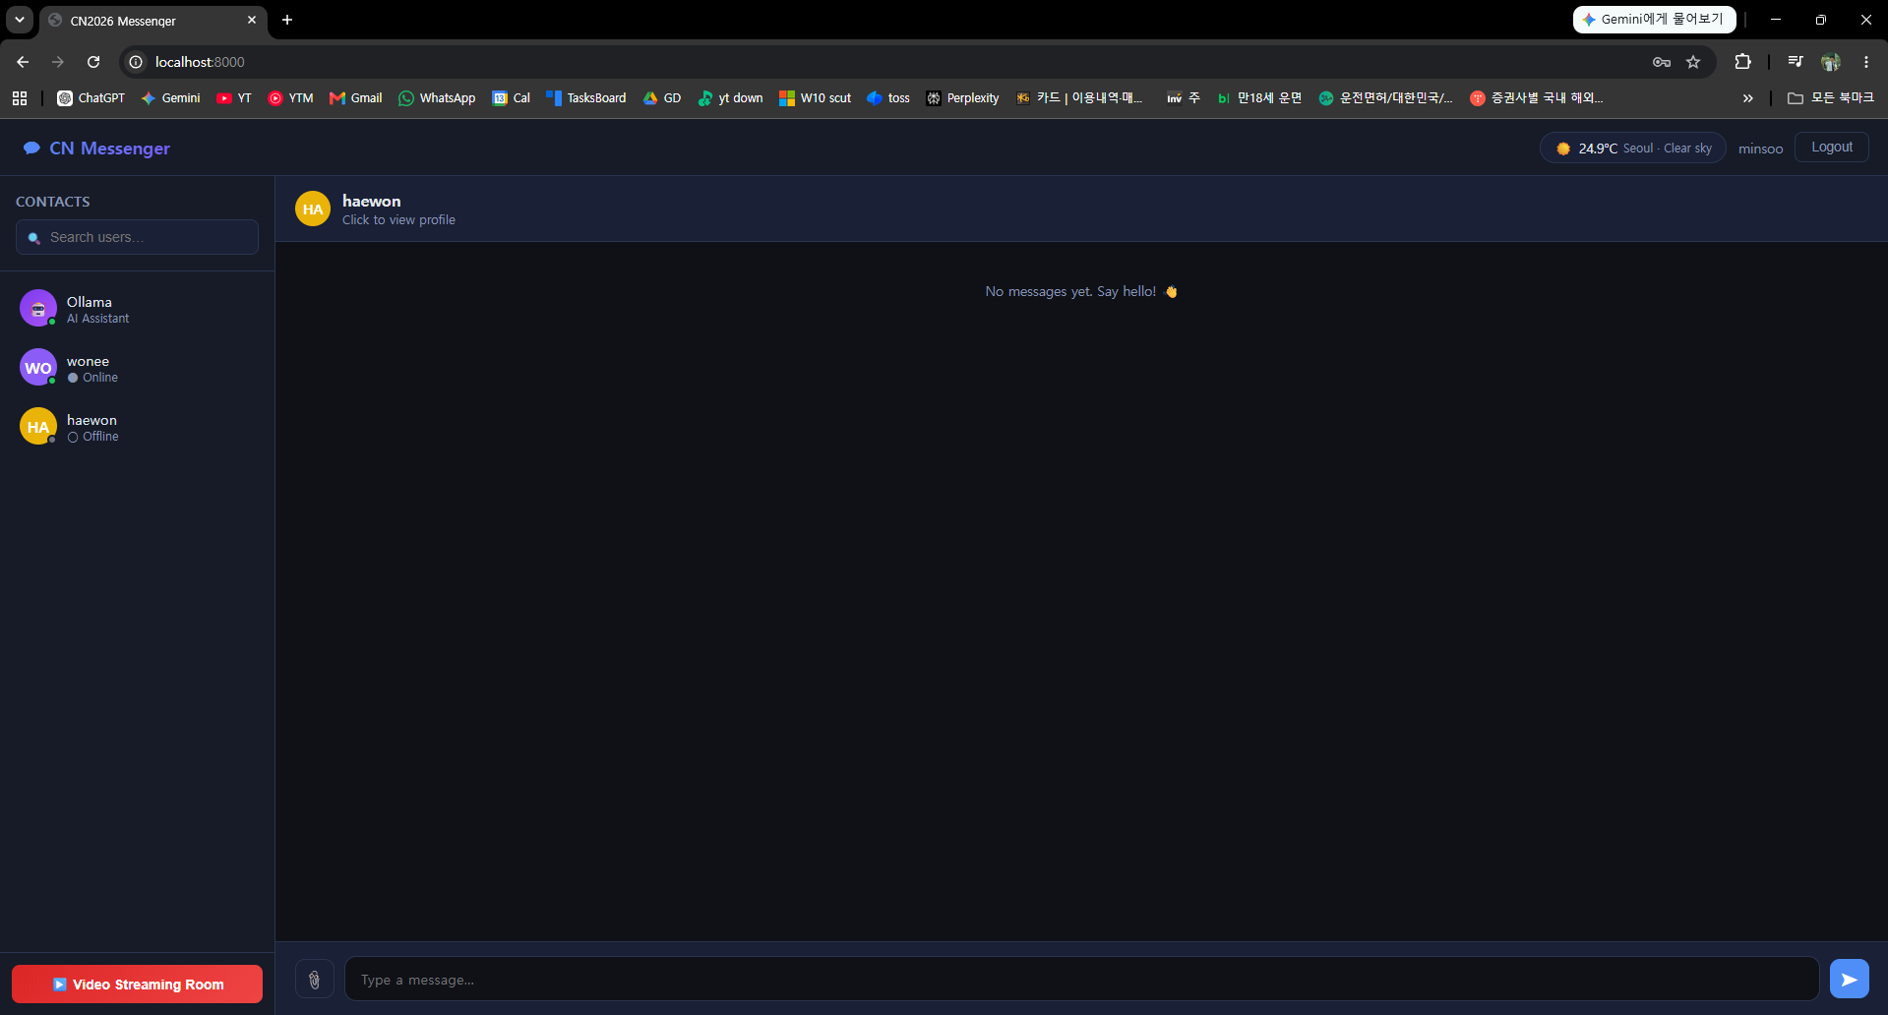
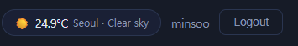
Figure 12. External weather API
Explanation of how this final project integrates concepts from
HW1, HW2, and HW4.

Homework 5, Problem 6 acts as a capstone project that unifies the standalone applications I built throughout the semester into a single, cohesive web application. Here is how it integrates the concepts from previous assignments:
- HW1 (TCP/UDP Client-Server Communication): HW1 laid the foundation for basic TCP and UDP client-server communication architectures. HW5 builds upon this networking foundation to create a complete application-layer network system. Instead of basic raw sockets, this final system utilizes HTTP and WebSockets to handle the application's communication over the web.
- HW2 (Authenticated Multi-Client Chatting): HW2 required implementing a TCP server that supported multiple clients simultaneously. It also introduced user authentication, requiring sign up and login functionalities while storing user accounts and password hashes in a SQLite database. HW5 directly incorporates these exact features by requiring a SQLite-backed user authentication system for signing up, logging in, and logging out. It takes the basic terminal-based multi-client chat and elevates it into a real-time, user-to-user web-based messenger.
- HW4 (Real-Time Video Streaming): HW4 involved building a socket-based streaming server to send a prepared video file (e.g., sample.mp4) to multiple clients. HW5 integrates this by featuring a server-provided video streaming room. Similar to the constraints of HW4, it explicitly states that the streaming room only needs to serve a prepared video file from the server, such as sample.mp4, and does not require complex live camera inputs, webcam streaming, or WebRTC.
Ultimately, HW5 Problem 6 wraps all of these previously isolated systems into one unified messenger-style web application. It also expands on them by introducing entirely new integrations, including file upload and download capabilities through the chat, an Ollama-based AI assistant, and external APIs to fetch weather information.

Read README.md file for Setup & Run Instructions

